- Configuring OSPF Practical

Q1. Using Cisco Packet Tracer, create a network topology with three routers in two OSPF areas (Area 0 and Area 1), and assign appropriate IP addresses to all interfaces?

Answer
- I created a network topology using three routers (Router0, Router1, and Router2) in Cisco Packet Tracer.
- I connected the routers using Ethernet cables and assigned IP addresses with a /30 subnet mask.
- The network was divided into two OSPF areas: Area 0 (Backbone) and Area 1. Router1 was selected as the Area Border Router (ABR) to connect both areas.
- After configuring the IP addresses, I tested connectivity between directly connected routers using the ping command.

- Result: All three routers were connected and ready for OSPF configuration.

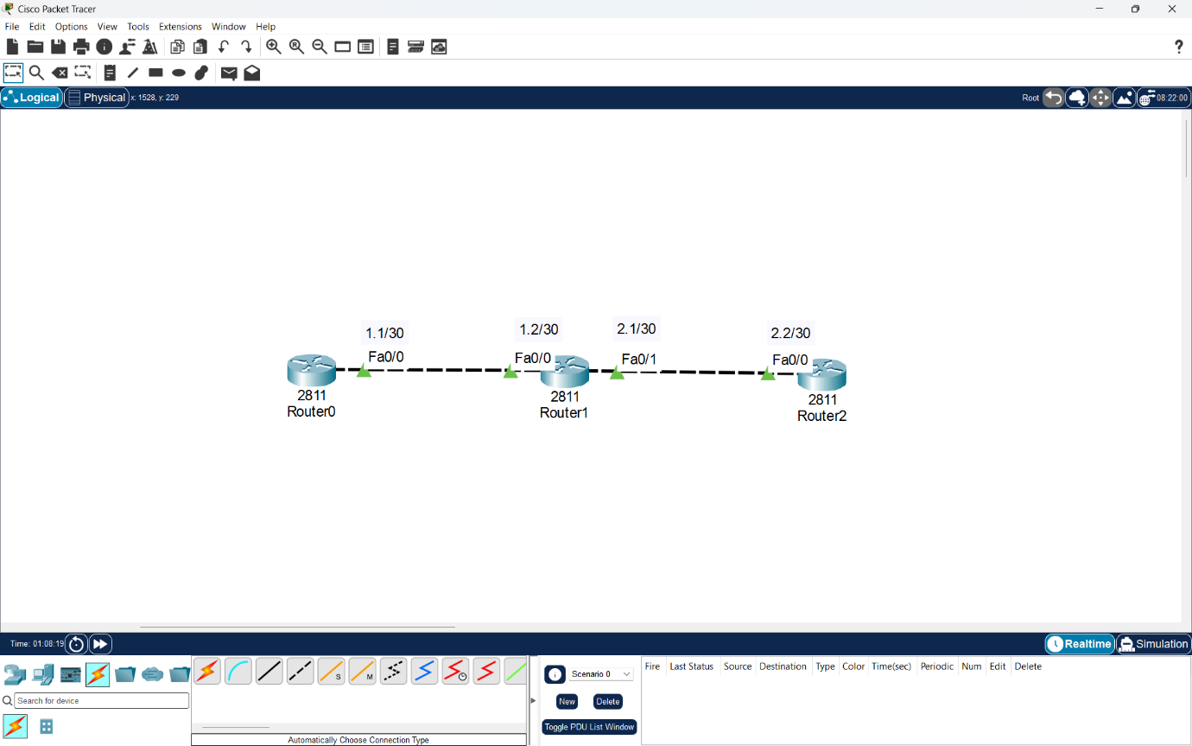

Q2. Configure OSPF on each router in your topology so that Area 0 acts as the backbone and Area 1 connects through one of the routers; verify OSPF neighbor relationships using the 'show ip ospf neighbor' command?

Answer
- I configured OSPF on three routers in Cisco Packet Tracer using OSPF process ID 1.
- Router0 was configured in Area 0, Router2 was configured in Area 1, and Router1 was configured as an Area Border Router (ABR) connecting both areas.
- I used the network command with wildcard masks to advertise the connected networks.
- After configuring OSPF, I used the show ip ospf neighbor command to verify neighbor relationships and show ip route to check OSPF-learned routes.
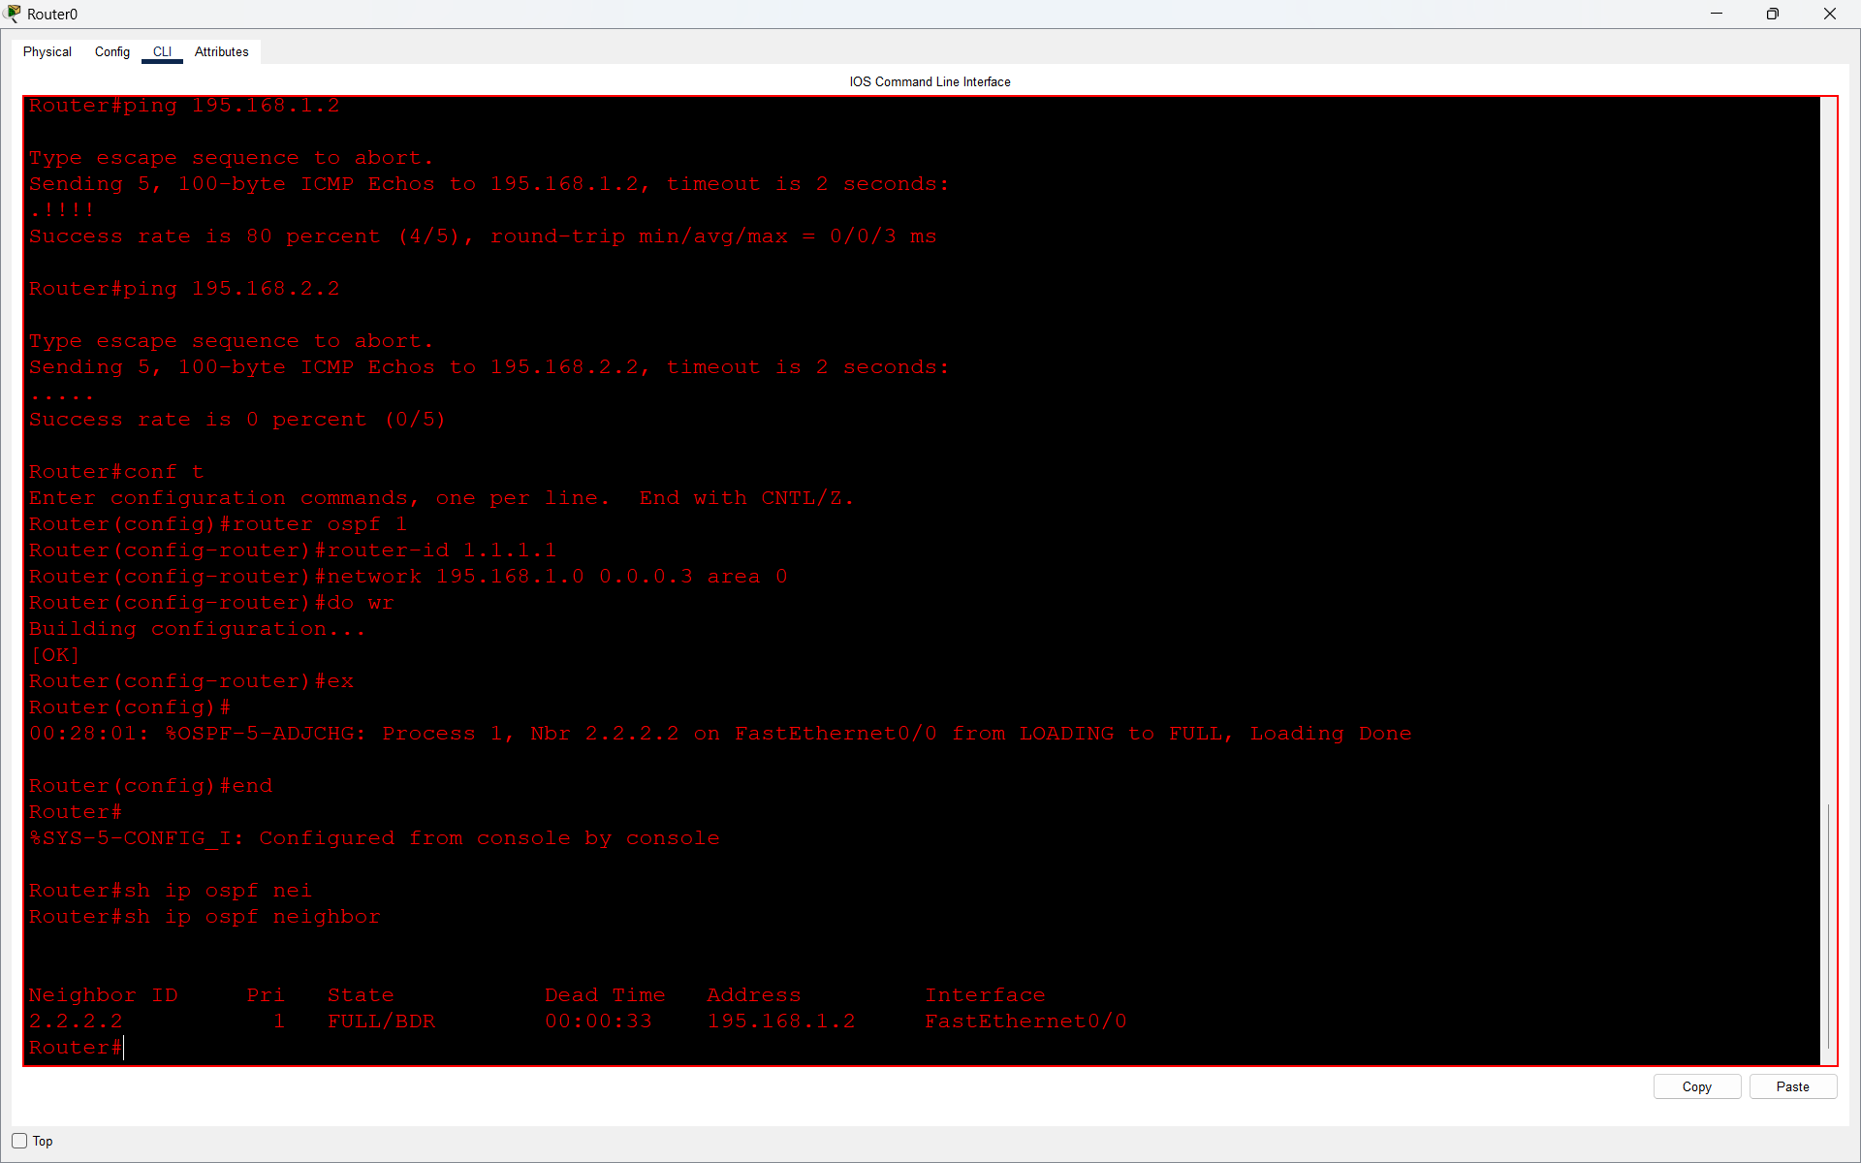
- Result: OSPF allows the routers to form neighbor relationships and exchange routing information between Area 0 and Area 1.

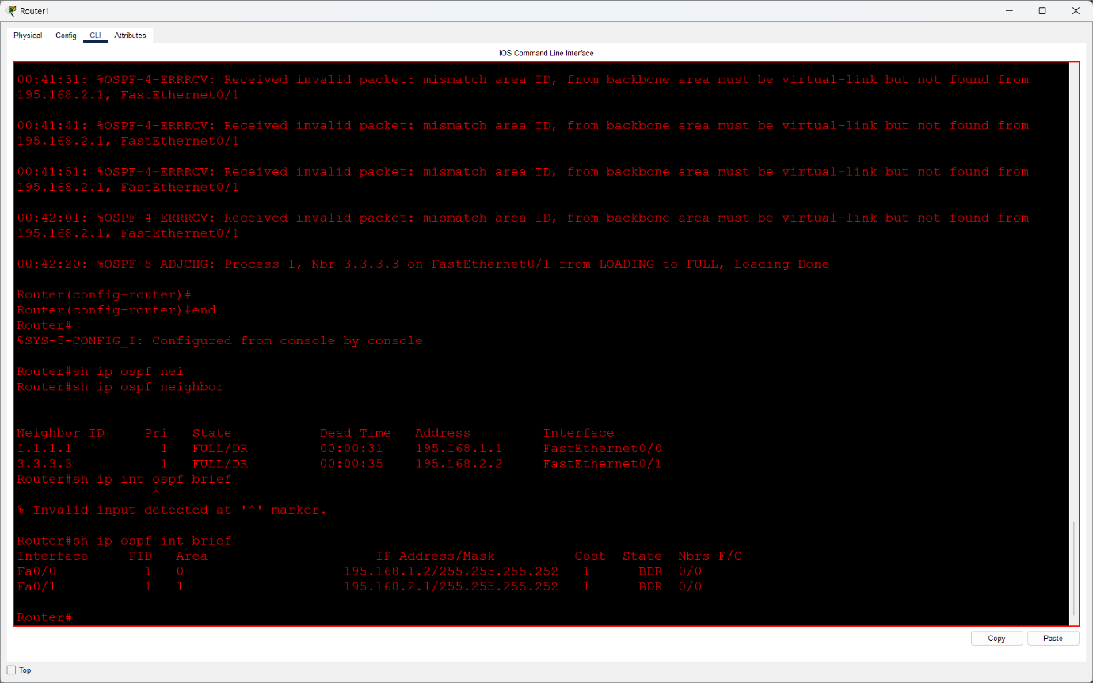
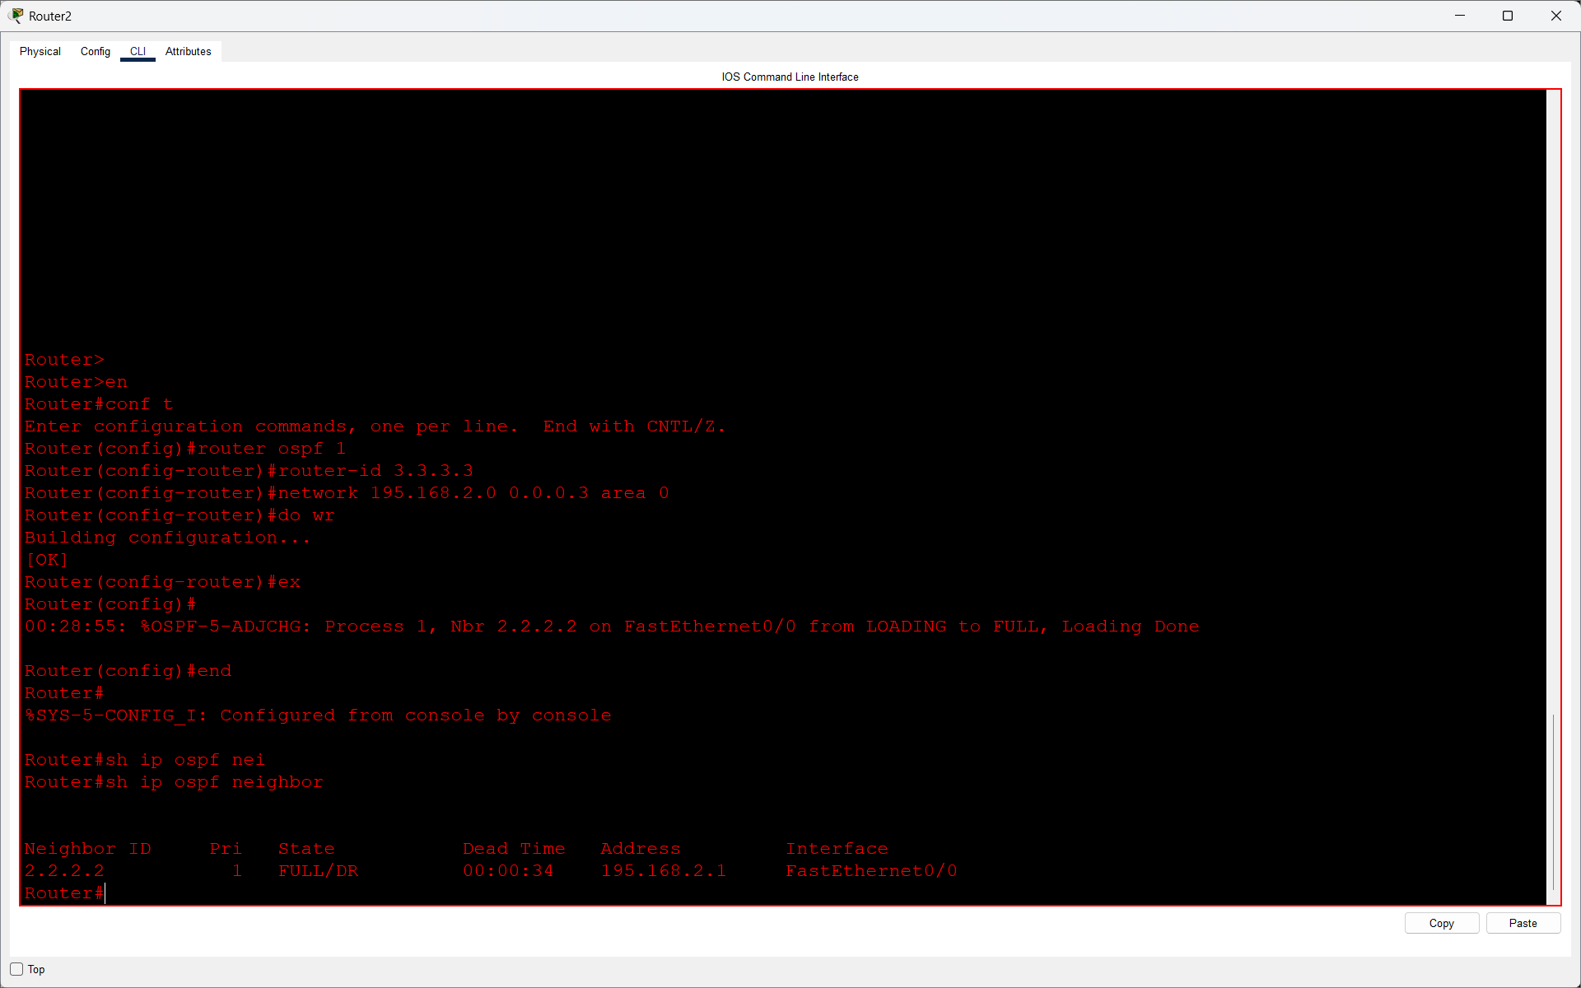

Q3. Add two PCs to different areas in your OSPF network, assign them IP addresses, and test connectivity by pinging from one PC to the other?

Answer
Q3. Answer:
- I connected four PCs to my OSPF network using two switches in Cisco Packet Tracer.
- Two PCs were connected to Router0 in Area 0, and two PCs were connected to Router2 in Area 1.
- I configured the LAN networks using /26 subnet masks and advertised them in OSPF.
- After configuration, I tested connectivity by pinging from a PC in Area 0 to a PC in Area 1.
- Result: The ping was successful, showing that both OSPF areas can communicate through Router1 (Area Border Router).
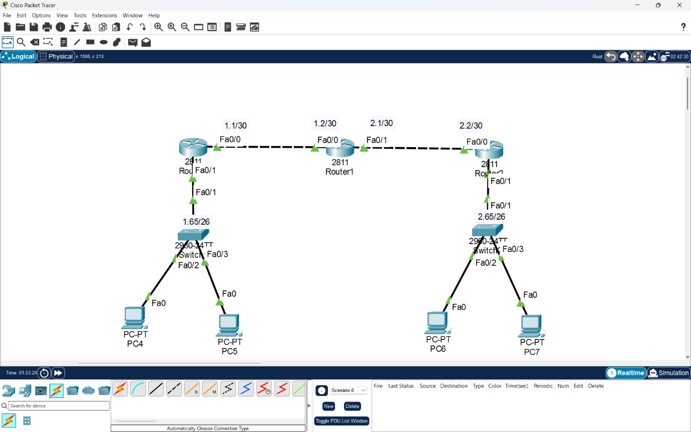

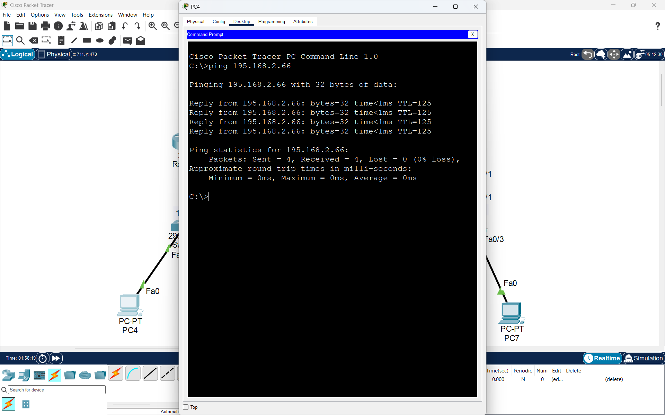

Q4. Simulate a router failure by shutting down the interface connecting Area 1 to Area 0, then use 'show ip route' and 'show ip ospf' commands to observe how OSPF reconverges and restores connectivity after re-enabling the interface.<br><br><em><strong>Hint:</strong> Track the time it takes for OSPF to update the routing tables after the failure and recovery.</em>?

Answer
- I used my existing multi-area OSPF topology in Cisco Packet Tracer with three routers.
- First, I checked the routing table using the show ip route and show ip ospf commands.
- Then I shut down the FastEthernet0/1 interface on Router1, which connects Area 0 to Area 1.
- After the interface shutdown, OSPF detected the network failure and removed the unreachable Area 1 network from the routing table.
- I restored the connection using the no shutdown command. OSPF formed the neighbor relationship again and restored the route.
- Observation Table:
Parameter | Observation
- Routing Protocol | OSPF
- Backbone Area | Area 0
- Second Area | Area 1
- Area Border Router | Router1
- Failed Interface | FastEthernet0/1
- Affected LAN | 195.168.2.64/26
- Administrative Distance | 110
- Route Removal Time | Not measured
- Route Recovery Time | Not measured

- Commands Used:
show ip route
show ip ospf
interface fastEthernet 0/1
shutdown
no shutdown
- Result: OSPF can automatically update routing information after a connection failure and restore connectivity when the interface becomes active again.

